
Wipro PARI Group
Standard Functions

Overview
Usage information of Lock and Unlock Block Add In.
Item Name: | Lock And Unlock Block Add In
Classification: | Tools
Item Code: | <<Item Code>>
Reviewed By: | Sainath Basutkar | Reference Project Code | NA

Version History
Version No. | Date | Revision By | Revision Note(s)
1.0 | 06-04-2026 | Sushant Y. Patil | Initial release
Created by | Sushant Y. Patil
Approved by | Sainath Basutkar

Description/Functionality
Overview:
Item | Description/Details
Hardware/Software Requirements | - Tia Portal V18, V19, V20  - Tia Openness V18, V19, V20
Memory requirements | 50 MB
Restrictions and Precautions | Preinstalled of Tia Portal V18, V19, V20 with openness.

Adding users to the "Siemens TIA Openness" user group
Procedure: -
- Search “Computer Management” in start menu.
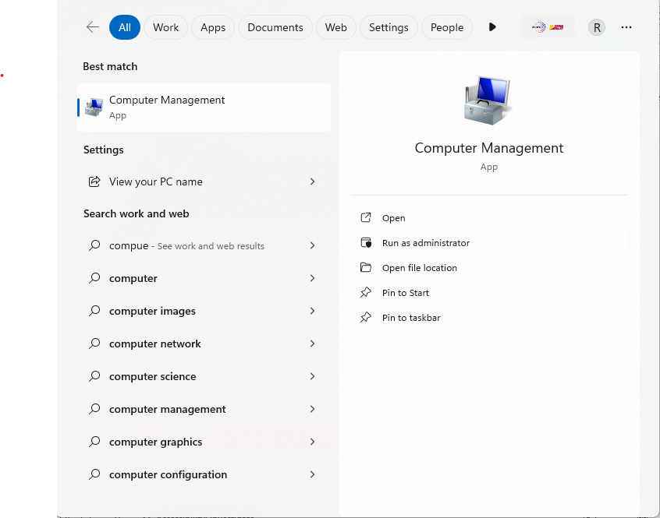
- Right click “Computer Management” and “Run as Administrator”.
- Select "Local Users and Groups” > “Groups", to display all created user groups.
- Select the "Siemens TIA Openness" entry from the list of user groups in the right panel.
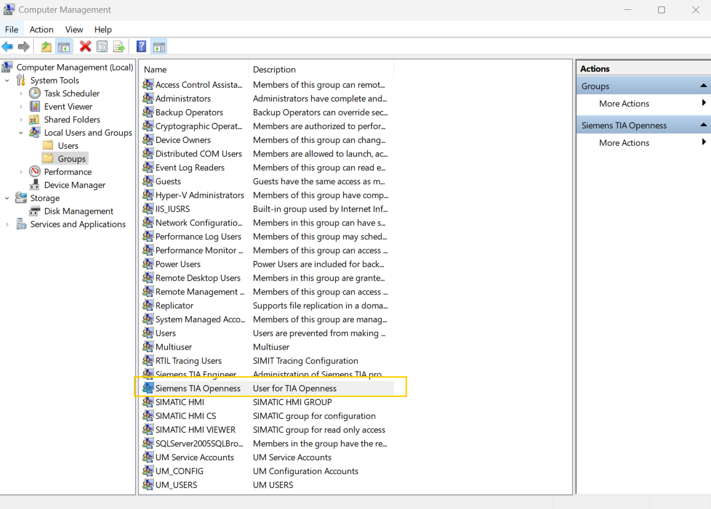

- Select the "Action” > “Add to Group..." menu command

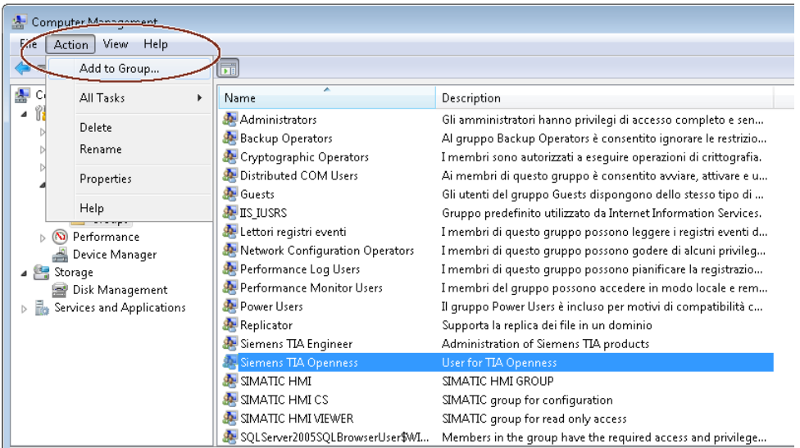

- The attributes dialog of the user group opens:
- Click "Add".
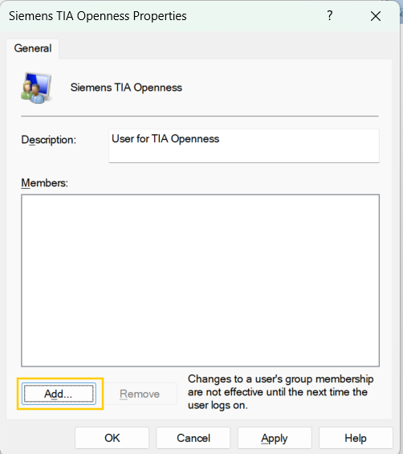
- The selection dialog that opens displays the users that can be selected
- Click “Locations”.

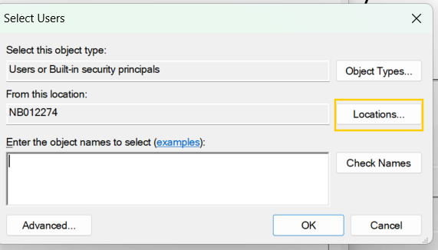

- “Cancel” Username and password window.
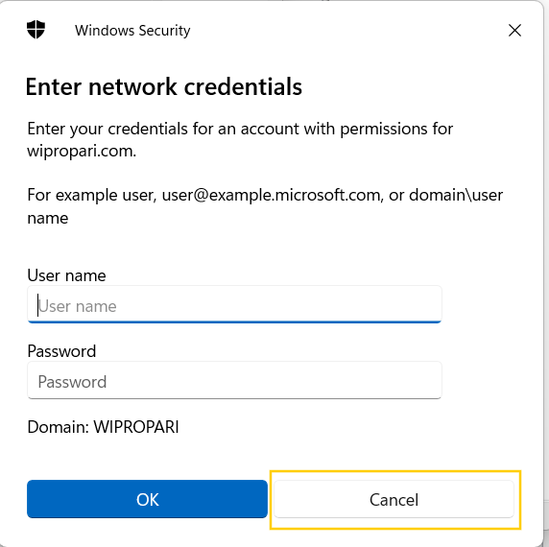

- Select PC Name and click on “OK”.
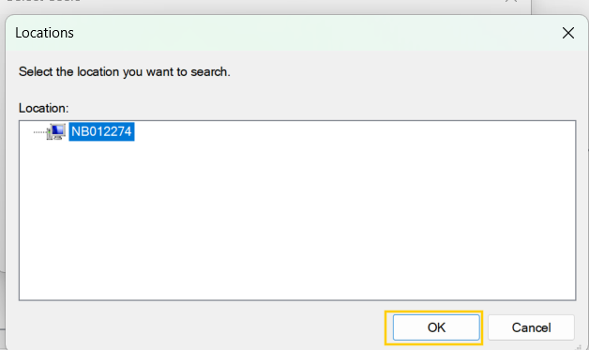

- Click “Advanced”-> “Find Now”. Select User from search results.
Click “OK”.
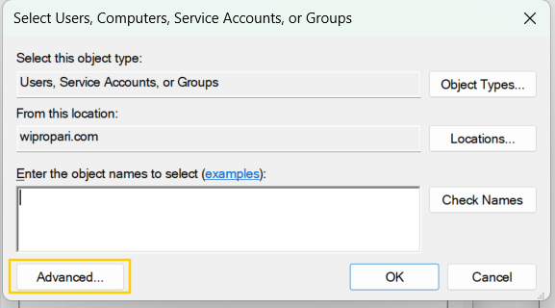
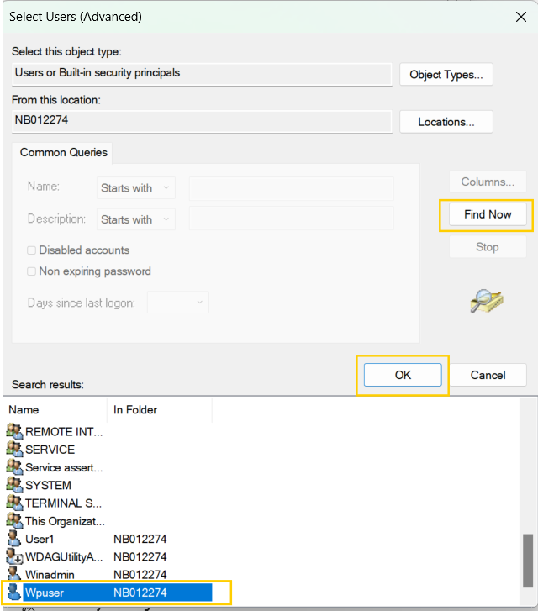
3
2
1

- Click “Check Names”, then Click “OK”.
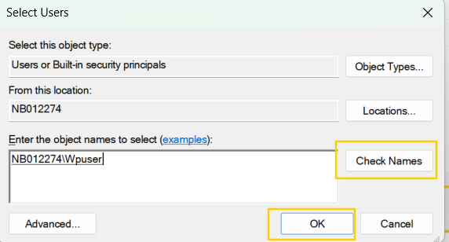
- See user added in group. Click on “Apply” then “Ok”.
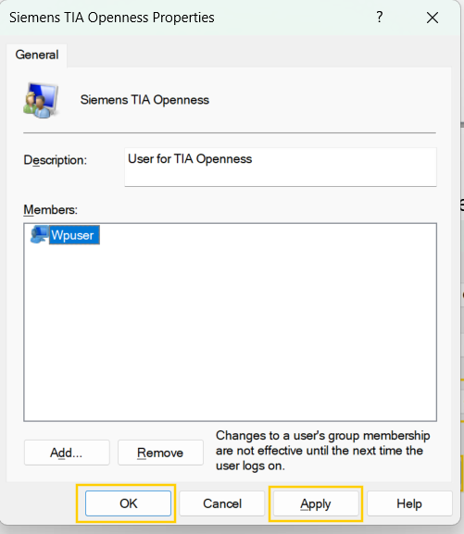

Usage Steps :
- Take the “Protect Block” folder from the authorized person and paste/add it into the C drive.
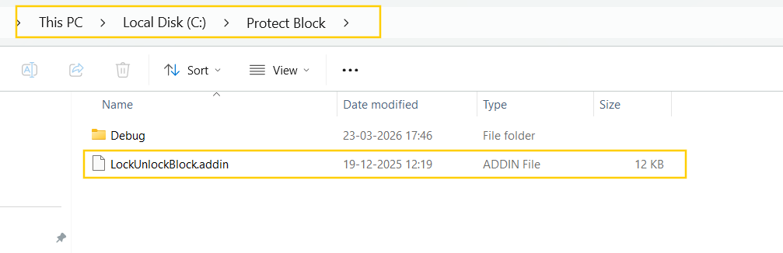
- Cut Paste the LockUnlockBlock.addin file on the below path
“C:\Program Files\Siemens\Automation\Portal V18\AddIns”
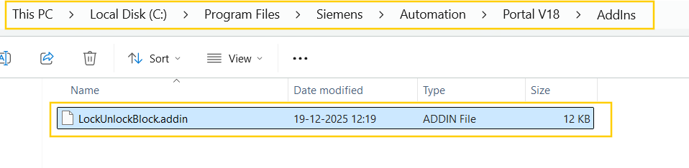

- Activate Add In.
Open the Project Select “Add-Ins” > “Activate” from the drop-down menu.
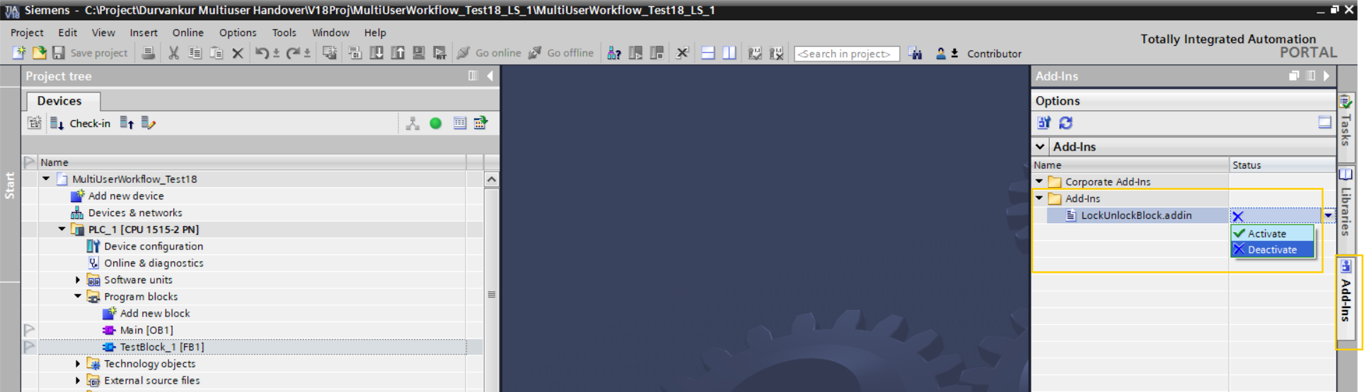

Click On “Yes” option.
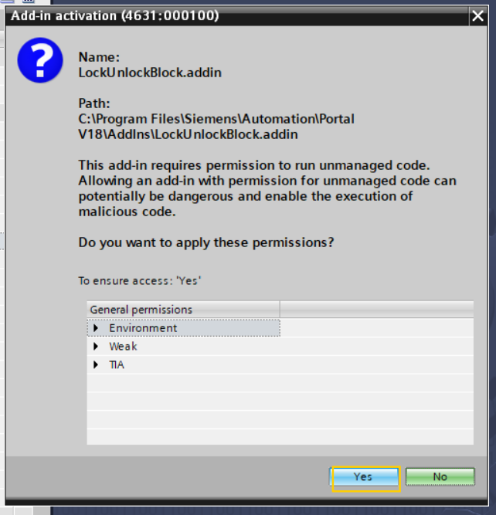

LOCK block for write protection : Locks the block for the first time if write protection has not been applied previously or if the block is newly created.

Right click on the block, then click on “LOCK AND UNLOCK” > “LOCK”.
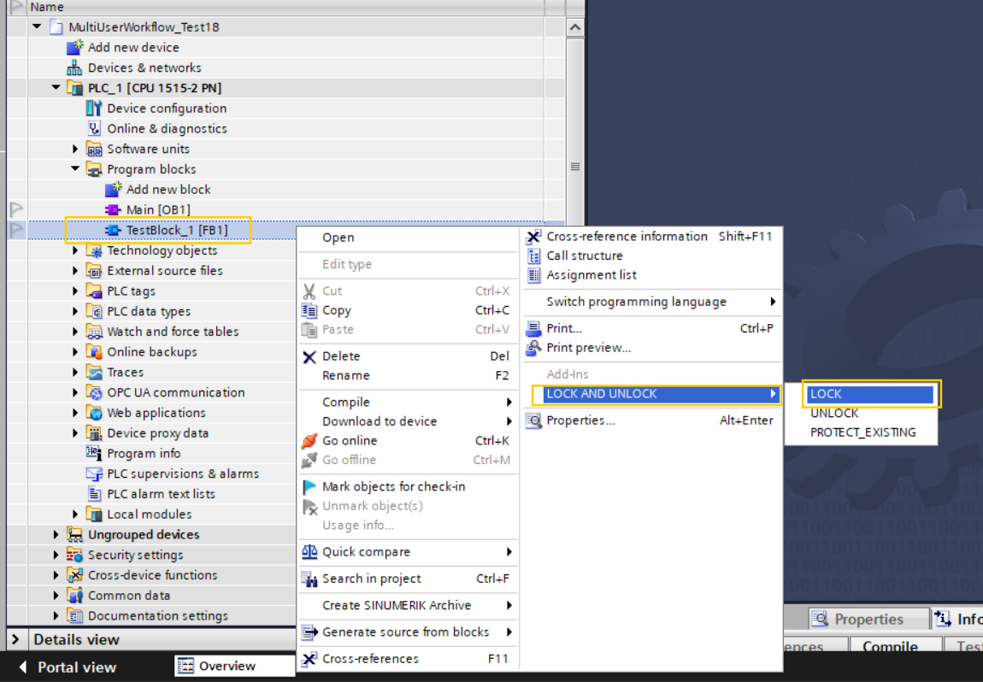

After starting the process, the following steps run automatically, and the user needs to wait.
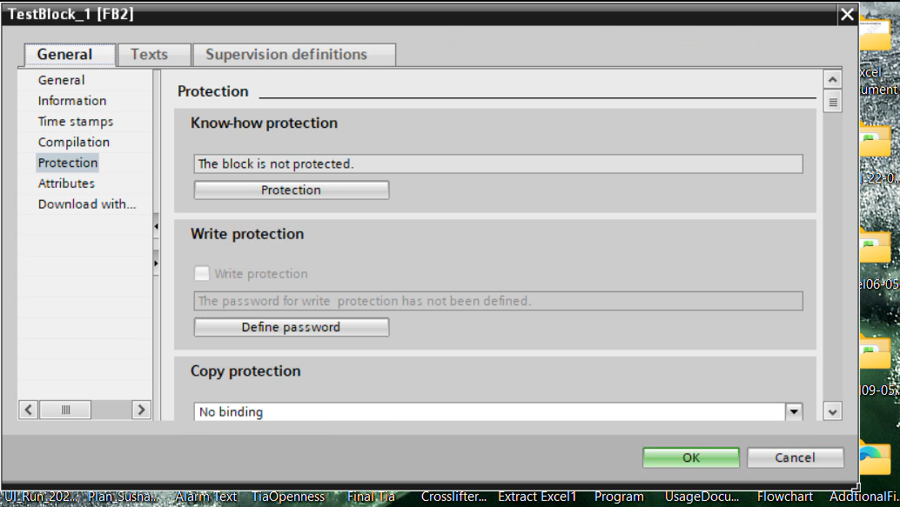
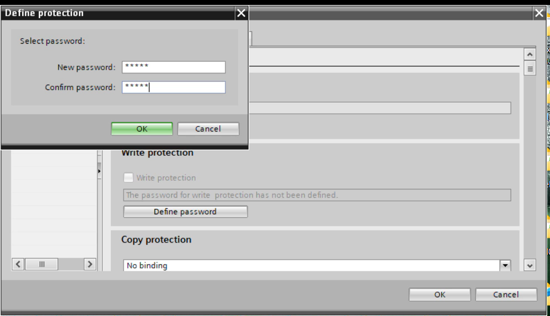
Note :
1. During this process do not switch the tia portal project window.
2. To avoid errors, open the respective block that the user wants to lock and ensure that it does not display the warning: “The block can only be read because it is write-protected.”
After completing the process, write protection is applied to the block using the predefined password.
After Protection applied to the block it show pop up.
Click on “OK”.
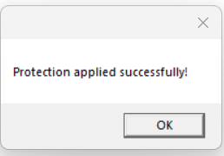
Also, the user sees a warning dialog box after opening the locked block, displaying the message: “The block can only be read because it is write-protected.”
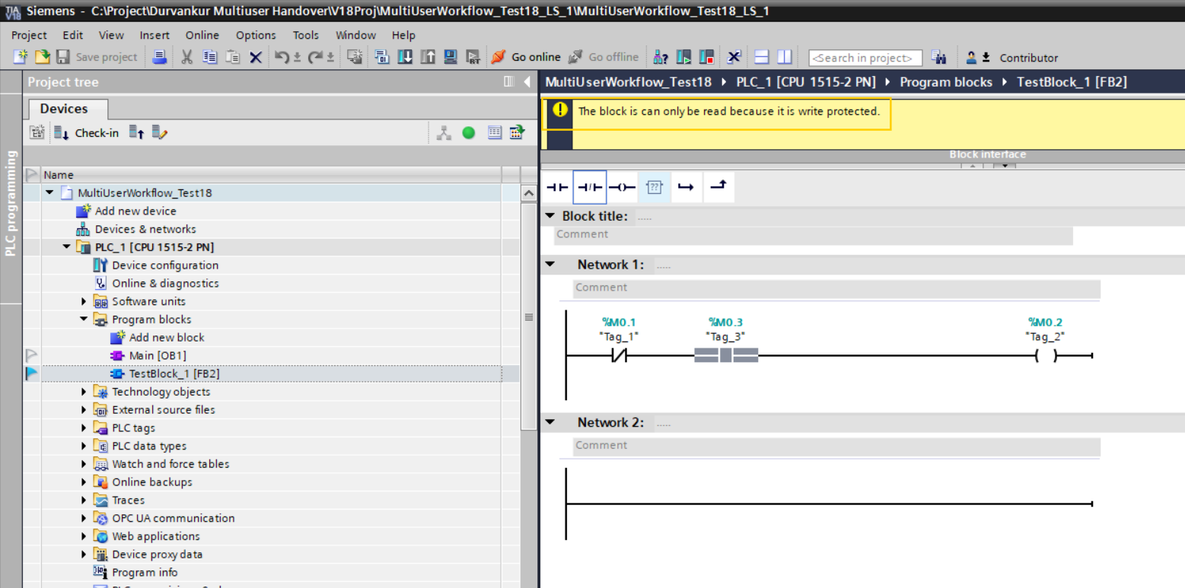

UNLOCK block : To Removes the write protection from a block if it is already applied.
Right click on the block, then click on “LOCK AND UNLOCK” > “UNLOCK”.
Note:
1.During this process do not switch the tia portal project window.
2. To avoid errors, open the respective block to be unlocked and check for the red-bordered warning related to write protection. Run the Unlock process only if the warning is present.
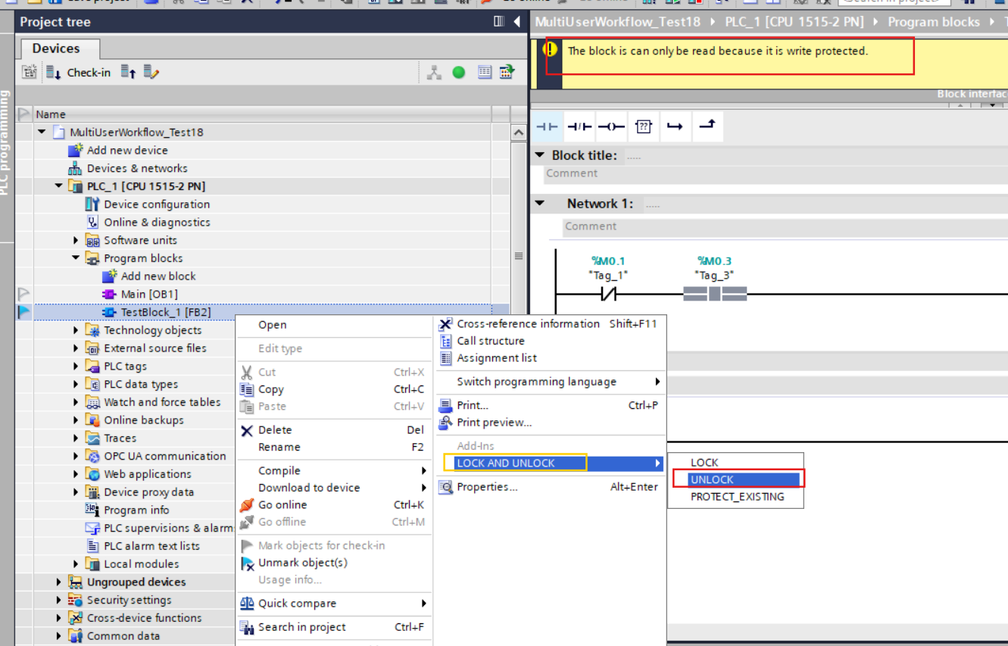

After start the process it runs the blow process automatically, user need to wait.
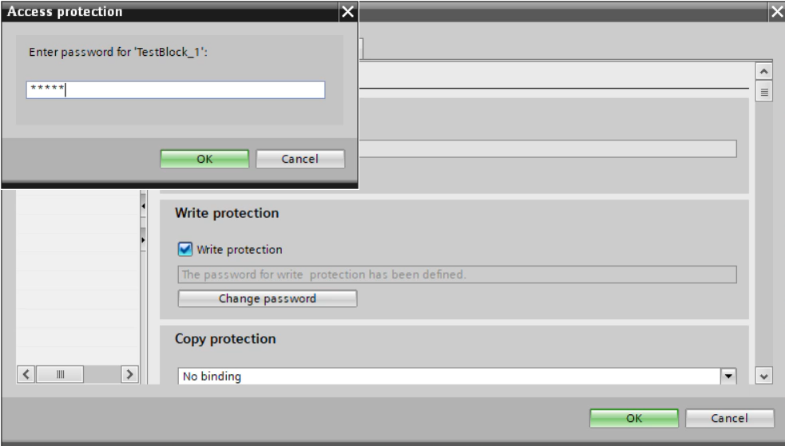
After Complete the process write protect is removed from the block using pre defined password and above window is disappear.
After block Write Protection is remove, it show below message.
Click on “OK”.
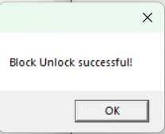

PROTECT_EXISTING : To Applies write protection again to a block that was previously protected and later unlocked.
Right click on the block, then click on “LOCK AND UNLOCK” > “PROTECT_EXISTING”.

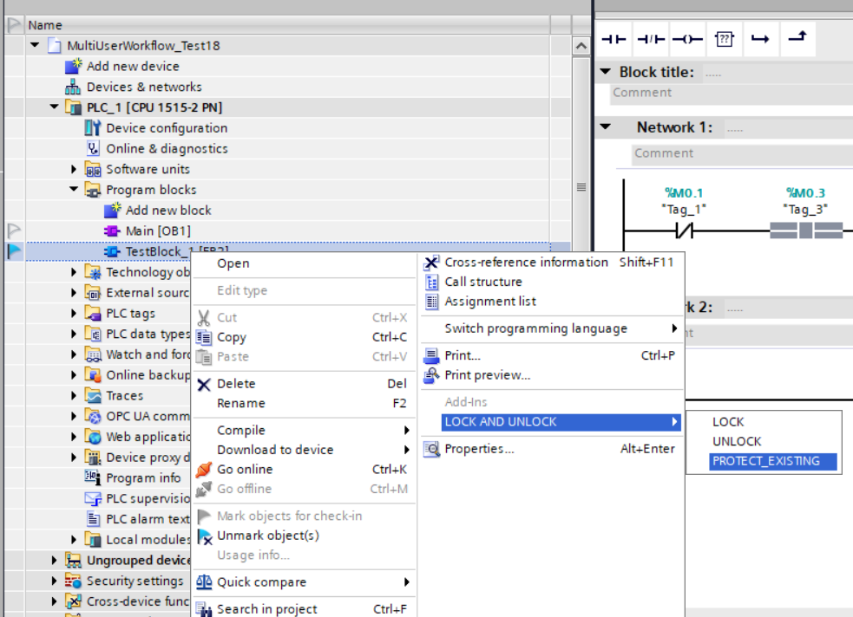
Note :
1. During this process do not switch the tia portal project window.
2. To avoid errors, open the respective block that the user wants to apply “PROTECT_EXISTING” and check for it not contains the worning like “The block is can only be read because it is write protected.”

After start the process it runs the blow process automatically, user need to wait.
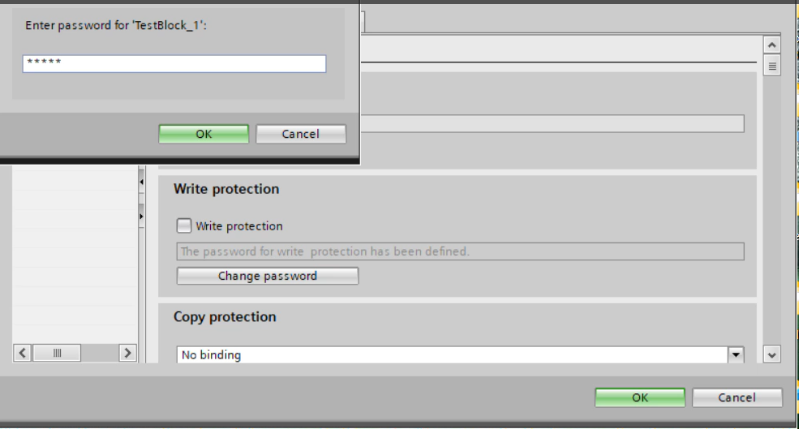
After completing the process, “PROTECT_EXISTING” applies write protection to the block using the predefined password.
After Write Protection applied to the block it show message pop up.
Click on “OK”.
Also, the user sees a warning dialog box after opening the locked block, displaying the message: “The block can only be read because it is write-protected.”

- Possible user errors and scenarios
- If the user clicks on “Unlock” when the block has not been previously locked:
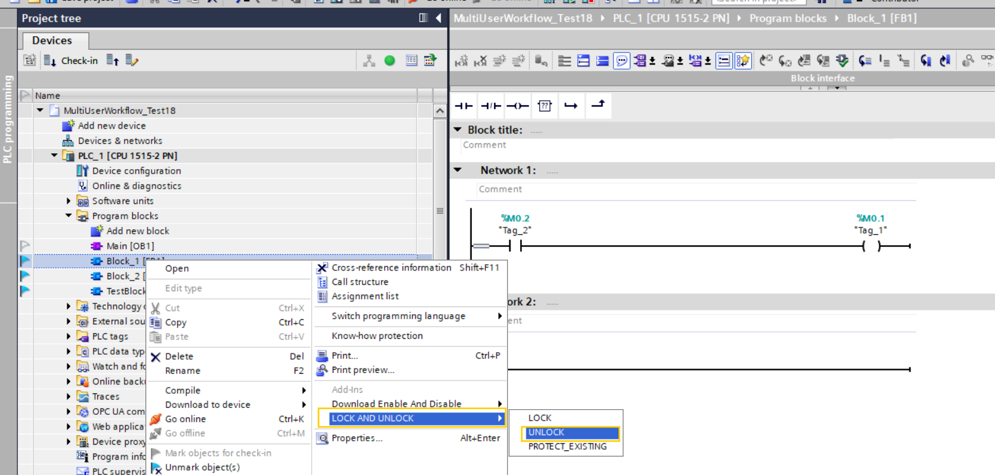

The current TIA Portal project is minimized, and a pop-up is displayed with the error message: “Block is not locked.”
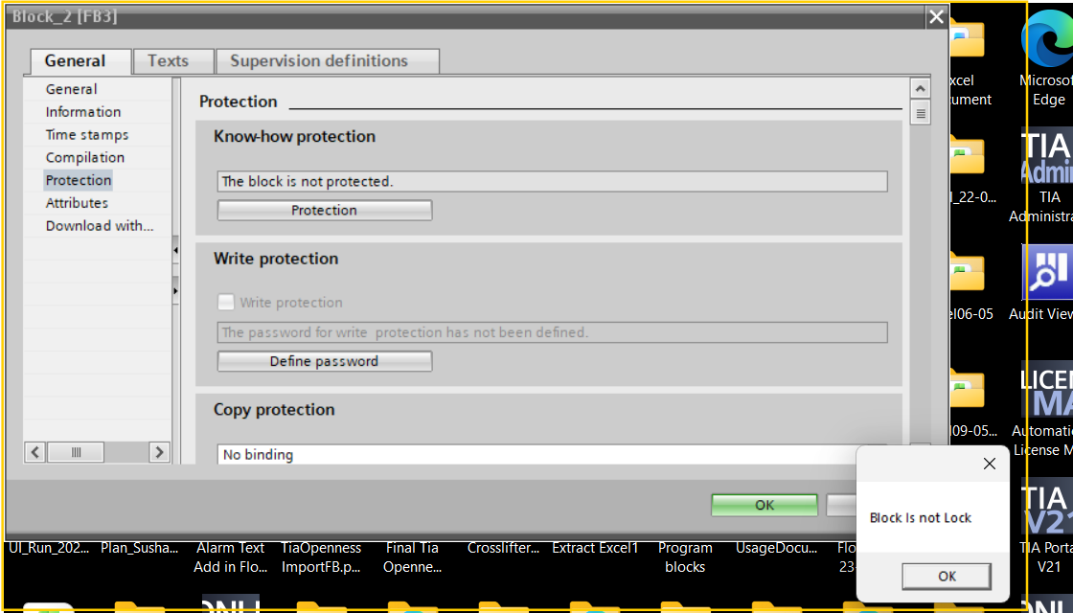
Click “Cancel” and reopen the minimized project.
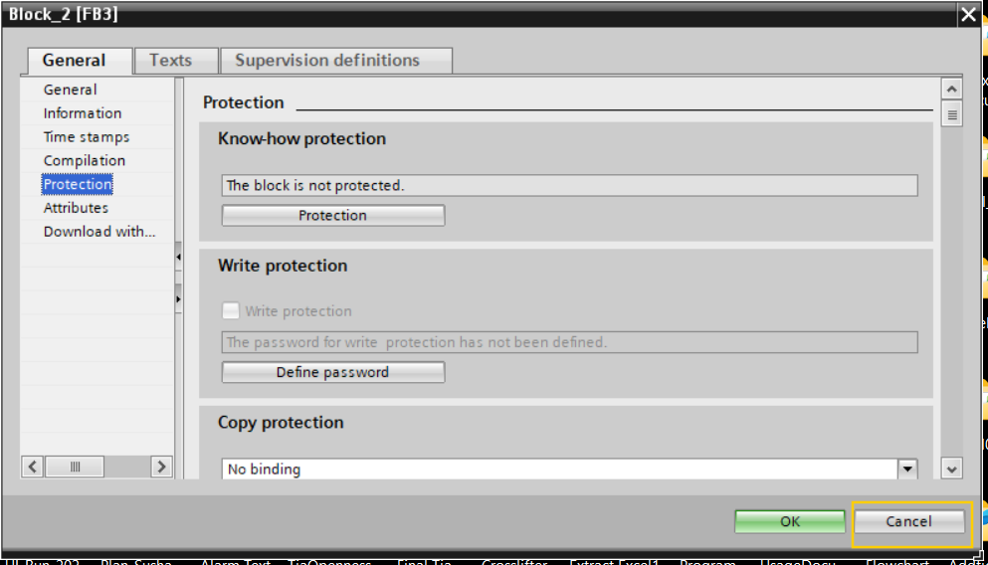

- If the block has not been previously locked or unlocked and the user clicks on “PROTECT_EXISTING”:
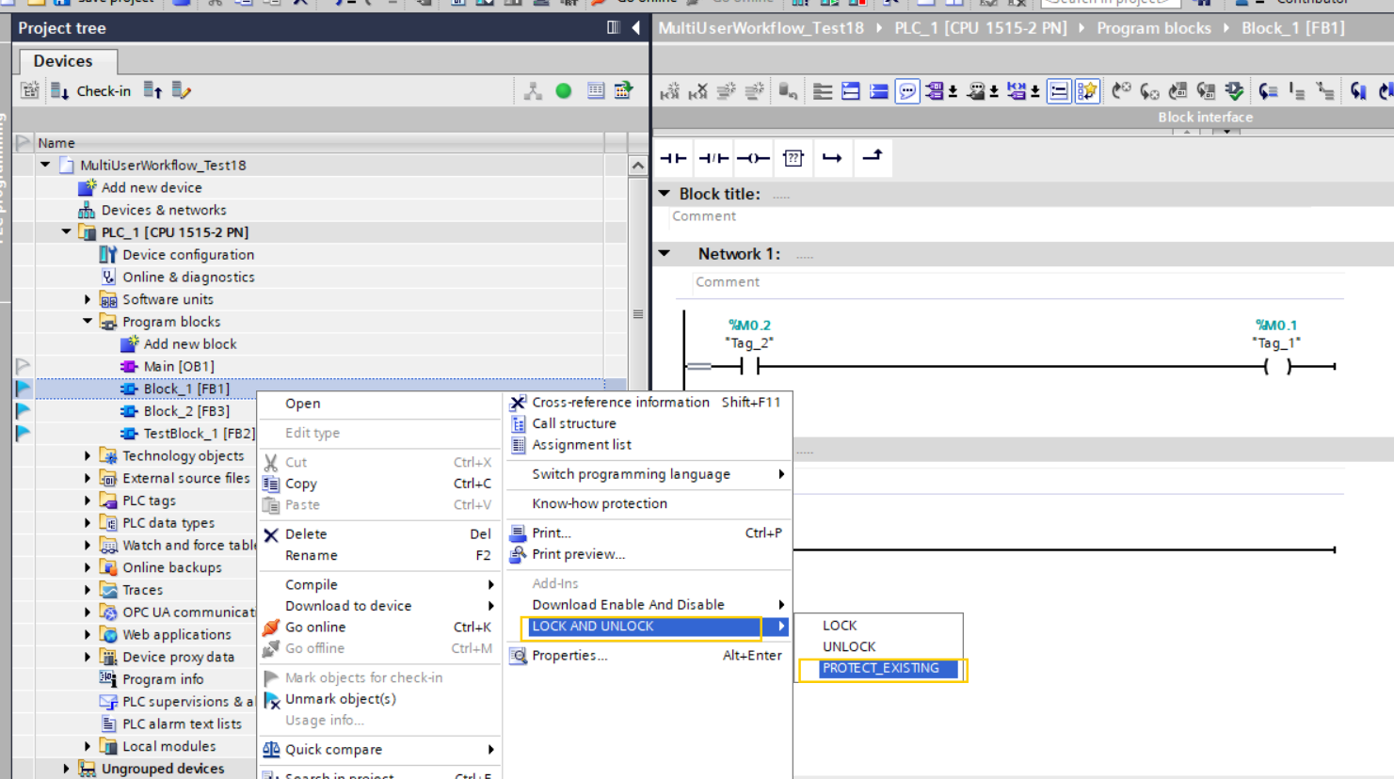
The current TIA Portal project is minimized, and a pop-up is displayed with the error message: “Block was not previously locked. Please check with the Lock option.”
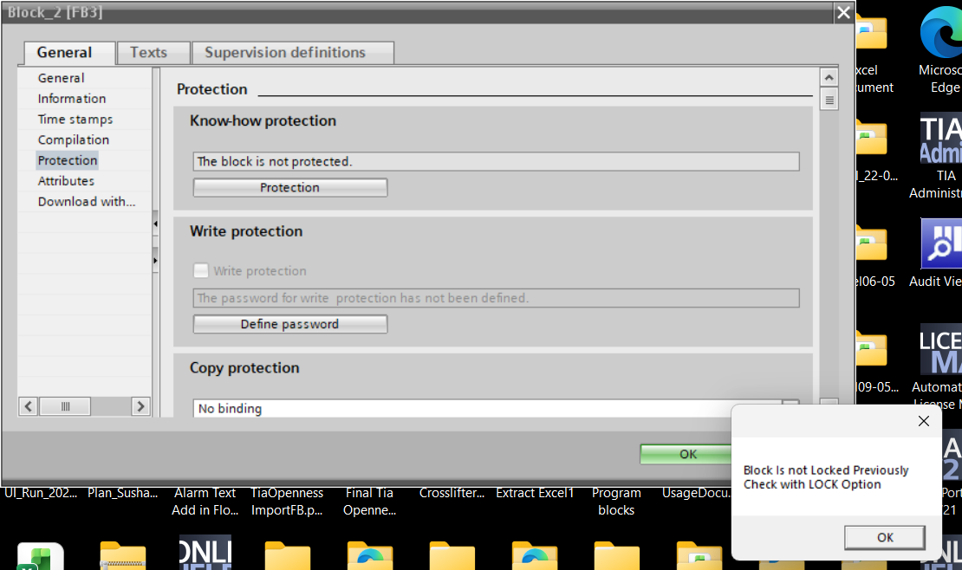
Click “Cancel” and reopen the minimized project.

- If the block is already locked and the user clicks the “Lock” option again:
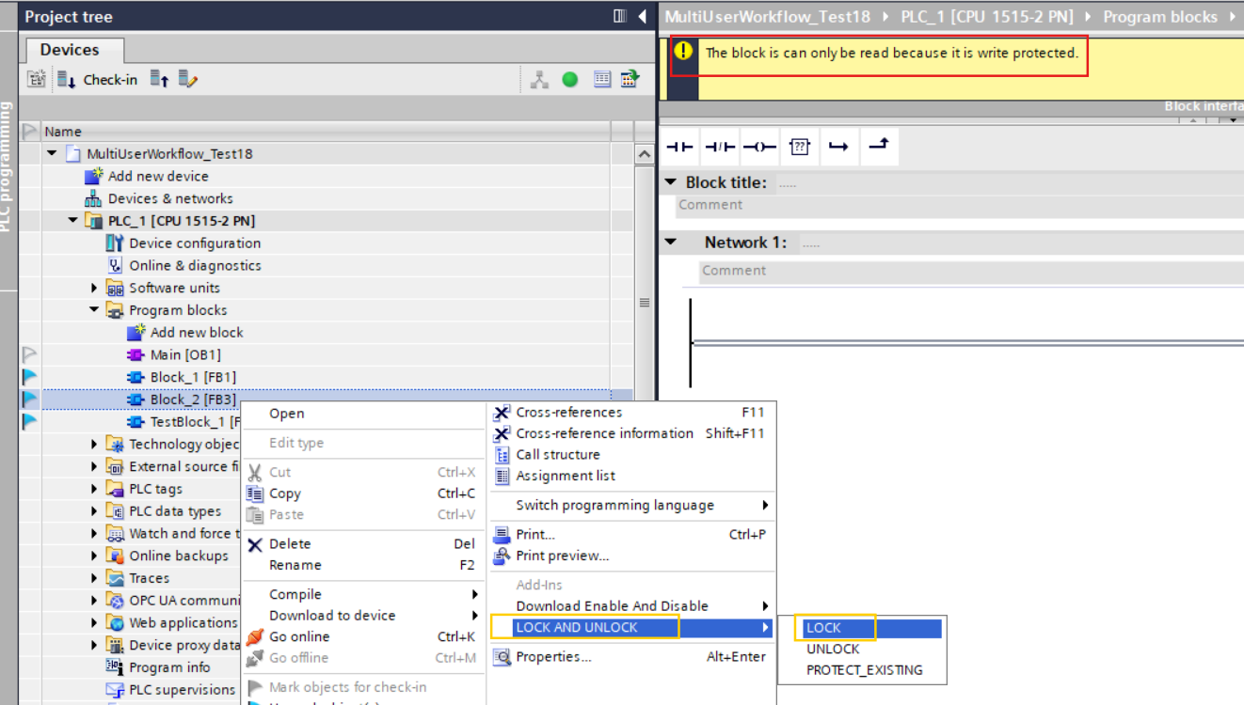

The current TIA Portal project is minimized, and a pop-up is displayed with the error message: “Object reference not set to an instance of an object. LOCK is not applied due to the above error. Please check the Protect_Existing option.”
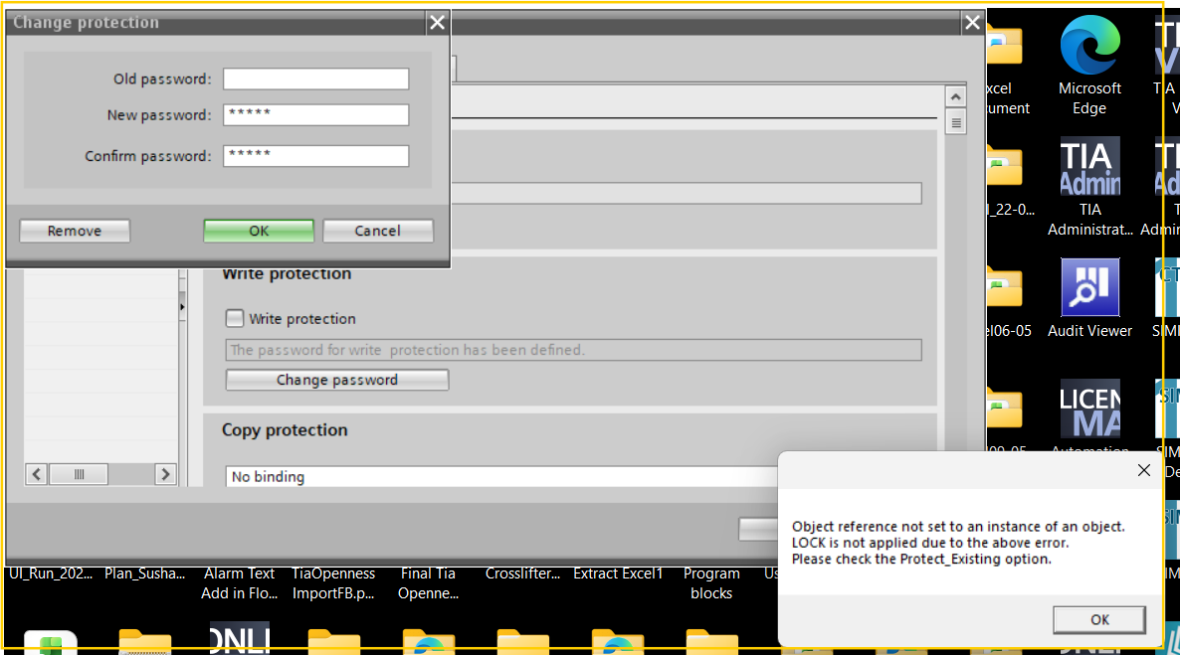
Click “Cancel” and reopen the minimized project.


